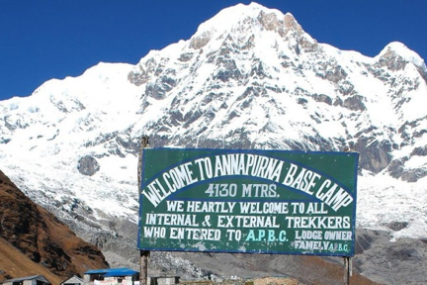

Driftwood Adventures- Annapurna Base Camp Trek
The trek will be a spectacular journey on foot to the South Face of
Annapurna, all the while staying in the best Tea Houses. We will be focusing on Yoga, Photography workshops and Cultural immersion. The Annapurna Base Camp trek will expose you to mountain ranges that are magnificent, colossal and snow-capped against the most brilliant blue sky. We will hike through ethnically diverse villages along with forests with different flora and fauna. Trek upstream along the Modi Khola into the Annapurna sanctuary, a valley surrounded by towering Himalayan peaks. When we reach the Annapurna Base Camp you will be surrounded by the panoramic and picturesque views of the Annapurna Mountain range, Tent Peak, Hiunchuli, Gangapurna, and Annapurna South. Their beauty is indescribable!
Our hope is that each member of our group will have the opportunity to engage with the local villages and communities; learn how they live, laugh and see life. Through genuine interactions we will create an opportunity to tell a story through a lens different than our own. No matter what camera you own - even if it’s just an iPhone - we will help you tell a story that you can share. Our camera is not only a tool, but a way to use our hearts to connect and capture an amazing culture.
If you have an open mind, a sense of adventure and are willing to step outside your comfort zone, then this is the trip for you! We will immerse you in a culture that is warm and very welcoming. There will be opportunities to work on landscape and portrait photography, as well as some videography. This is a personalized trip for the travel adventurer, as well as for those who love exploring new cultures. It is not a trip for those faint at heart.

“Courage is the power to let go of the familiar.”

Destination: Annapurna Base Camp

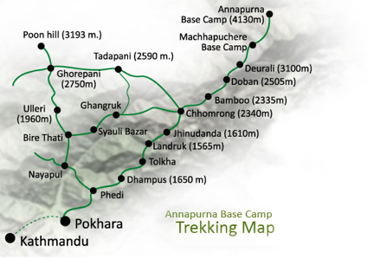

Best Season: February, March, April, May, June, September, October, November & December Country Visited: Nepal

Trip Route: Ktm-Pokhara-Ghorepani-Poon Hill-Chomrong-Himalaya Hotel-Machhapuchere Base Camp - Annapurna Base Camp - Bamboo-Nayapul-Pokhara-Ktm
Trip Style: Lodge to Lodge Trekking
Activity: Sightseeing, Trekking and Photography Max. Altitude: 4,130 m /13546.4 ft
Activity Per Day:Approximately 5hrs walking per day.
Trip Highlights
Impressive Sunrise and mountain views from Ghorepani and Poon Hill Typical Gurung village along the trekking route
Fishtail (Machhapuchhre) Base Camp
Spectacular mountain and glacier views from Annapurna Base Camp Natural Bath in hot spring at Jhinu
Photography Workshops through out the trek.
Itinerary
***Trip starts and ends in Kathmandu

April 17 Day 01: Arrive in Kathmandu (4264 ft)
Upon our arrival in the Tribhuwan International Airport (TIA) in Kathmandu, we will be greeted by a representative from Malla Treks P Ltd. He or she will escort you to the hotel; there will be a briefing on the trek arrangement. Overnight in Kathmandu at Hotel shangrila.
(Breakfast Included)
18 April Day 02- Pre-trip Meeting and Sightseeing around Kathmandu valley.
After a hearty breakfast, at 8.30 am your sightseeing trip will start. You will have a private vehicle and a professional tour guide at your disposal. Today we will visit some heritages listed below:
Pashupatinath: Pashupatinath Temple is one of the most significant Hindu temples of Lord Shiva in the world, located on the banks of the Bagmati River. Though you are not allowed to go inside the temple as it is strictly for Hindus only, you can clearly see the temple and the activities from the eastern bank of the BagmatiRiver. It is a square two tiered pagoda temple built on a single tier pinth which is famous all over the world.
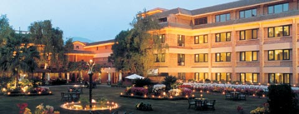
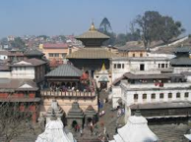
Boudhanath: Boudhananath is one of the holiest Buddhist sites in Kathmandu. It was built in 5th century with four pairs of eyes of Lord Buddha in four cardinal directions keeping an eternal watch over the people and their doings. You will find Buddhist pilgrims from Tibet going round the stupa spinning the prayer wheels.
Bhaktapur Durbar Square: Visit the Bhaktapur Durbar Square, the Royal Residential Quarter of BhupatindraMalla,famous five-storied temple of Nyatapola in Pagoda style Batsalatemple,Bhairavnathtemple,Duttatrayatemple,PujariMuth and Palace of 55 windows.
The rest of our time in Kathmandu is free for further exploration and some last-minute shopping in Thamel area near by your hotel. Overnight at Hotel Shangrila.
(Breakfast Included)
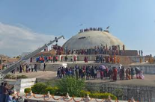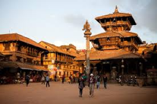
19 April Day 03: Kathmandu to Pokhara by flight – Drive to Nayapul(1010M)- 1 hr. Trek to Tikhedunga (15,70M)- 3 Hrs
In the morning, we take a scenic flight to Pokhara ( 2,700ft) , passing over the deep valley and rivers of central Nepal and taking views of the Ganesh , Dhaulagiri and Annapurna Himals..
We begin our trek at Nayapul after a 1-hour drive on a private vehicle from Pokhara. After a short 15-minute walk along the banks of the Modi Khola, we reach Birethanti (1,015m) a large village with many shops and teahouses. From there, the trail continues through the village and follows the north bank of the Bhurungdi Khola. The trail climbs steadily up the side of the valley to Hille at 1,495m and after a short climb, we reach Tikhedhunga at 1,570m. Today’s walk is relatively short and easy, a prelude to the trekking experience in the Annapurna region. Overnight at a guesthouse.
(Breakfast, Lunch and Dinner Included)
20 April Day 04 - Trek to Ghorepani (2,840m) - 5 hrs
We move on towards the steep climb to Ulleri, a large Magar village at an altitude of 2,070m. The trail ascends more gently from this point, through fine forests of oak and rhododendrons towards Banthanti at 2,250m. Then we trek towards Nangethanti at 2,460m. After an hour walk we arrive at Ghorepani (2,840m). Overnight at a guesthouse.
(Breakfast, Lunch and Dinner Included)
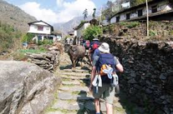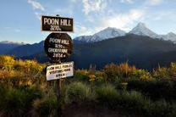
21 April Day 05 - Hike up to Poon Hill (3,210m); and trek to Tadapani (2,610m)
Today, very early in the morning, we start an hour hiking to Poon Hill at an elevation of 3,210m, a brilliant mountain range spectacle; this vantage point provides an unobstructed view of the sunrise over the high Himalayas. There we spend about 1 hour, then returning to Ghorepani we take a hot breakfast at a hotel. Then we make a climb along ridges, and through pine and rhododendron forests to Deurali (2,960m). After that we descend to the Banthanti, then turning off to Tadapani. Overnight at a guesthouse.
(Breakfast, Lunch and Dinner Included)
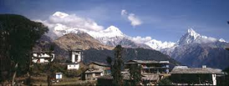
22 April Day 06 - Trek to Chommrong (2,140m) - 5 hrs
The day starts with a steep downhill through rhododendron forests. Leaving Tadapani, we descend through the forests and then the trail eases as we reach Gurjung which is the village of Gurung people, with an easy walk to Chommrong at an elevation of 2,140 m. Overnight at a guesthouse.
(Breakfast, Lunch and Dinner Included)
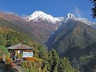
23 April Day 07 - Trek to Himalayan Hotel (2,950m) - 6 hrs
Today the trail drops down to the Chhomrong Khola and again we continue climbing to Khuldighar at 2,380m where there used to be an ACAP (Annapurna Conservation Area) check post. There is a clearing in the forest a little further on, from which, the route travels very steeply down a rock bank then levels out, running through thickets of bamboo at the bottom of the gorge, keeping always on the west side of the river. We walk through bamboo, then rhododendron forests to the Himalayan Hotel. Overnight at a guesthouse or tented camp
(Breakfast, Lunch and Dinner Included)
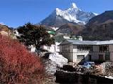
24 April Day 08 - Trek to Annapurna Base Camp (4,130m) - 7 hrs
Today the trail climbs on past the Hinko Cave, Deurali and then Machhapuchhare Base Camp, which isn’t really a base camp since climbing the mountain is not permitted. Since it is totally surrounded by mountains, this area is known as the Annapurna Sanctuary. Two hours trek from Machhapuchhare Base Camp takes you to the Annapurna Base Camp (ABC) at elevation of 4,130m. There, you will view unobstructed views of mountain scenery, which is very spectacular. Overnight at a guesthouse or Tented camp
(Breakfast, Lunch and Dinner Included)
25 April Day 09 - Trek back to Bamboo (2345m) - 6 hrs
We follow the same trail down today the trail drops by 1,700m to the bank of Modi Khola to Bamboo at 2,345m where there are a few teahouse/lodges available to stay at. Overnight at a guesthouse.
(Breakfast, Lunch and Dinner Included)
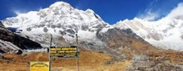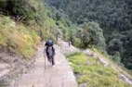
26 April Day 10 - Trek to Jhinu hot spring (1,780m) - 5 hrs
We follow the same trail until Chommrong. Once we have passed Khuldighar there is an experimental sheep farm, the trail continues through rhododendron and bamboo fields. From Chomrong the trail descends very steeply to the Jhinu hot spring, where you can bathe in natural hot springs. Overnight at a guesthouse.
(Breakfast, Lunch and Dinner Included)
27 April Day 11 - Trek to Nayapul (1,010 m) - 4.5 hrs. Drive to Pokhara - 1 hr. Same day guided tour of Barahi Temple and Boating in Fewa Lake.
From Jhinu hot springs we walk at the right side of Modi Khola for 4.5 hrs to Birethanti which can be considered one of the best and the most relaxing walks of the entire trek. We reach Nayapul then an hour drive will take us back to Pokhara.
After we check in to hotel we will then walk to the Fewa Lake for our boating trip to Barahi Temple and than back to hotel. Overnight at Shangrila Village resort hotel.
(Breakfast and Lunch Included)
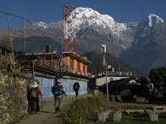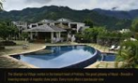
28 Apr Day 12: Fly back to Pokharato Kathmandu
After morning breakfast we check in the airport to fly back to Kathmandu. A 30 min dramatic flight to Kathmandu.
To celebrate the successful completion of our journey, we will have a farewell dinner in the evening. Overnight at shangrila Hotel
(Breakfast including)
29 April Day 13: Fly Home: Farewell Friend
You are saying good bye to the mountains as your journey in Nepal comes to an end today! We hope you enjoyed the tour with us, and are sure you`ll be back in your trip somewhere in the Himalaya again. Approximately 3 hours before your scheduled flight a representative from Malla Treks P ltd will transfer you to the airport. On your way home you'll have plenty of time to plan your next adventure in the wonderful country of Nepal.

Cost:
$3250.00 per person Twin sharing (above 5 members)
$550 (Single Supplement)
To reserve a space on this trek you will need to make a non-refundable deposit of 15% of trip cost at the time of booking the trip. You can pay the remaining amount before the trip departure. This can be done by check to Driftwood Adventures or by Paypal. Please talk to Briana Gallo.

Cost Includes
Airport / Hotel / Airport pick up & drop by private tourist vehicle.
twin sharing accommodation in a Five star hotel in Kathmandu; Breakfast included. (3 nights) & one night in Pokhara (Lunch , dinner and Breakfast Included)
Guided city tour in Kathmandu by private tourist vehicle.
All your standard Meals during the trek (Breakfasts, Lunches and Dinners).
T - house standard Lodges and Guesthouses accommodation during the trek. (we provide accommodation at Lodges which are mentioned in the details itinerary)
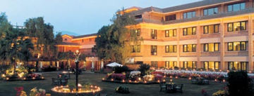
Local Malla Treks Nepal licensed English speaking guide.
The required number of local staff and porters to carry your luggage during the trek (We assign one porter for every two guests).
Food, accommodation, salary, insurance, equipment and medicine for all staff. Annapurna conservation fees and TIMS permit for trekking.
Down Jacket and sleeping bag by Malla Treks Nepal (which need to be returned after the trek).
Airfare from Kathmandu – pokhara- Kathmandu including airport departure tax in Kathmandu, Pokhara airport.
Surface transfer from and to Kathmandu.
Free Malla Treks duffel/ T-shirt (yours to keep). Sightseeing/Monument entrance fees in Kathmandu (On Day 2). All our government taxes, vat, tourist service charges.Official expenses.
Cost does not Include:
Travel insurance which covers emergency Rescue and Evacuation. International airfare and airport departure tax
Nepal entry visa; you can obtain a visa easily upon your arrival at Tribhuwan International Airport in Kathmandu. (Tourist Visa with Multiple Entries for 30 days can be obtained by paying US $ 40 or equivalent foreign currency. Similarly, Tourist Visa with Multiple Entries for 90 days can be obtained by paying US $ 100. Please bring 2 copies of passport size photos).
Alcoholic, hot and cold drinks.
Personal trekking Equipment (See the trekking equipment page).
Tips for trekking staff and driver (Tipping is expected).
Any others expenses which are not mentioned on 'Price Includes' section.

